Aesthetic: Pertaining to the idea of beauty

Goal is to convey a modern take on a religious dispute

Notes taken from looking at modern house designs

* Sleek, cold designs
* Sharp angles
* Off center, asymmetrical
* Layers, not everything is on the same level
* Spacious and open

Notes taken from looking at modern websites

* Uses cool and/or dark colors
* Softer designs, rounder edges as opposed to sharp angles
* Minimalistic

Notes from looking at religious architecture

* Tall, grandiose
* Emphasis on pointing up
* Intricate and detailed contrary to the modern design

Idea

Grandiose with details taking inspiration from modern designs

Modern Architecture examples

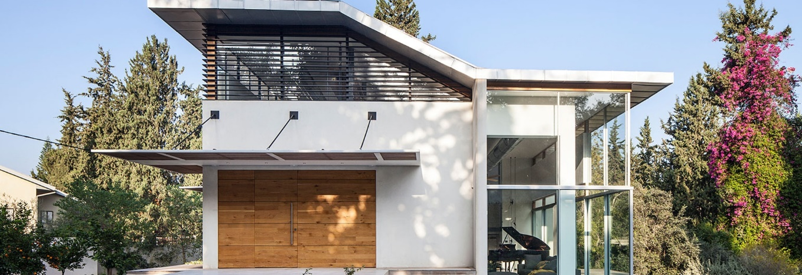

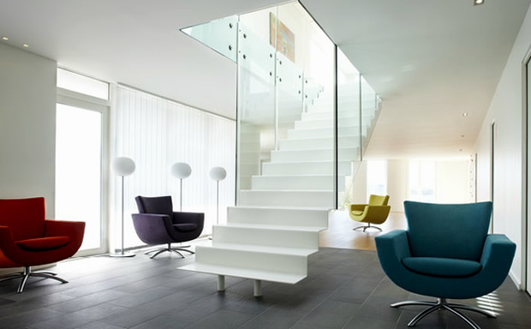

Modern Website examples



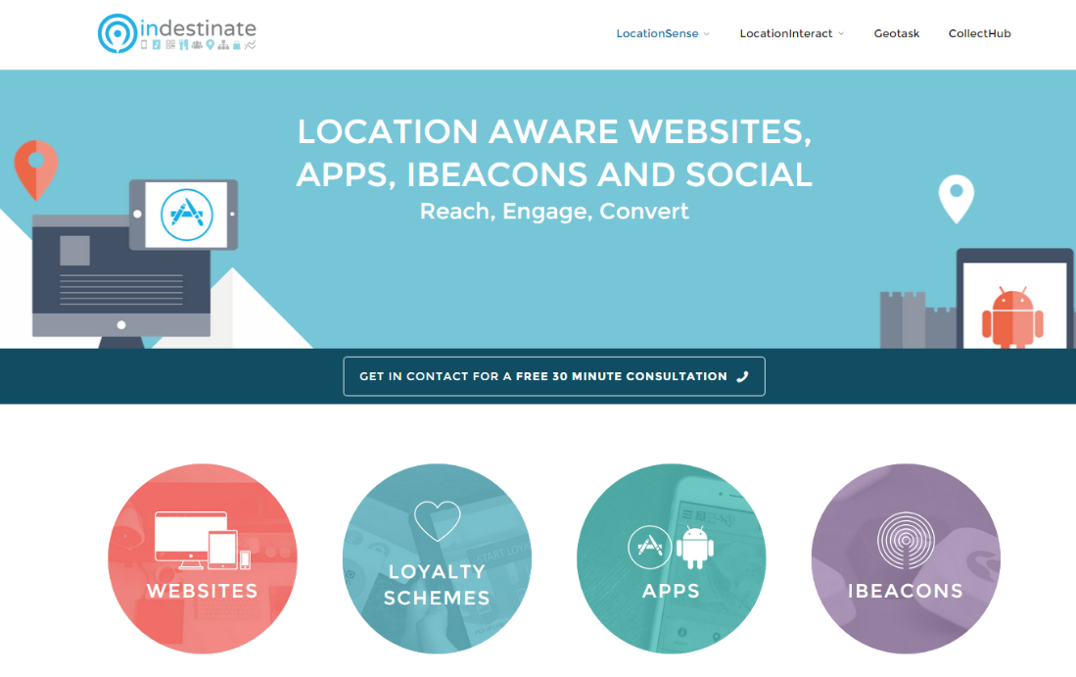

Religious Architecture examples

